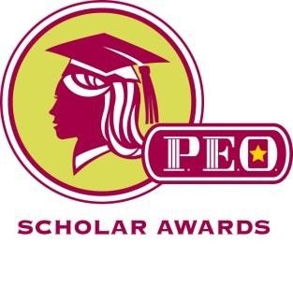

FOR IMMEDIATE RELEASE
HAILEE YOSHIZAKI GIBBONS HONORED WITH P.E.O. SCHOLAR AWARD

Hailee Yoshizaki Gibbons, a Ph.D. Candidate in Disability Studies at University of Illinois at Chicago, is one of 100 doctoral students in the U. S. and Canada selected to receive a $15,000 Scholar Award from the P.E.O. Sisterhood. She was sponsored by Chapter EQ of Oxford, Ohio, with the support of Chapter President Lynn Cronk and Chair of the P.E.O. Scholar Award Elisabeth Haley.

Hailee graduated from Miami University in 2008 with a Bachelor of Philosophy in Interdisciplinary Studies with a Concentration in Gerontology, Psychology, and Family Studies and in 2013 with a Master of Science in Student Affairs in Higher Education. Hailee is a recipient of University of Illinois at Chicago’s prestigious University Fellowship, as well as other honors including the Excellence in Undergraduate Mentoring Award and the Anne Hopkins Scholarship Award.

Hailee serves as a Graduate Student Instructor in the Disability and Human Development Undergraduate Program. Her research interests include intersections of aging and disability, dementia, mental disabilities, intersectionality, disability identity and disclosure, disability in higher education, service-learning, and qualitative methodology. Her dissertation focuses on women with dementia living in special care units of long-term care facilities.
Hailee Yoshizaki Gibbons

The P.E.O. Scholar Awards (PSA) were established in 1991 to provide substantial merit-based awards for women of the United States and Canada who are pursuing a doctoral-level degree at an accredited college or university. Scholar Awards recipients are a select group of women chosen for their high level of academic achievement and their potential for having a positive impact on society.

The P.E.O. Sisterhood, founded January 21, 1869, at Iowa Wesleyan College, Mount Pleasant, Iowa, is a philanthropic educational organization dedicated to supporting higher education for women. There are approximately 6,000 local chapters in the United States and Canada with nearly a quarter of a million active members.

Supporting Women…Changing the World

March 2017

